Lesson 3
Volume of Solid with known Cross Section
In basic geometry, we learn the formulas for the volume of different solids such as volume of a rectangular solid and the volume of a cylinder. The volume of these solids is computed as the product of the area of the base B times the height h of the object, that is, V = Bh. For instance, the volume of a rectangular solid is V = (L x W) x h where: L x W = B. The volume of a right cylinder is V = (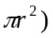x h where: (= B of the cylinder.
In this lesson, we will use cross section of a solid to define its volume. The term cross section can be used to describe a typical portion of some object or body. In the physical sciences, the term cross section is used to describe a slice perpendicular to an axis of an object. In this context a cross section can be used to represent a typical slice of an object.
For a solid whose cross sections are the same shape and size, the volume of the solid is computed as the product of the area of the cross section times the height of the object. The height can be a vertical distance or a horizontal distance as illustrated in Figures 1 and 2. Note that the height is measured along the axis of the object (perpendicular to the cross section).
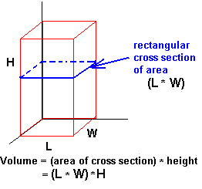
Figure 1.

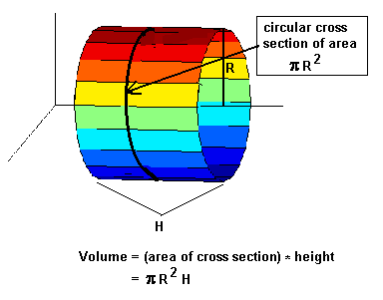
Figure 2.
For more general solids in which the cross section is the same shape, but not the same size, we use integral calculus to determine the volume. We use the Infinite Sum Theorem to derive a formula for the volume of a solid when the area of each cross section is known. Suppose a solid S extends in the direction of the x-axis from x = a to x = b, and for each x the plane perpendicular to the x-axis cuts the solid in a region of area A(x), as shown in Figure 3. The area A(x) is called the cross section of the solid at x. The volume is given by the formula:
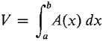
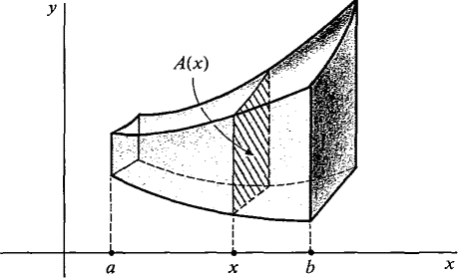
Figure 3.
JUSTIFICATION
Slice the solid S into vertical slabs of infinitesimal thickness Δx, as in Figure 4. Each slab, between x and x + Δx, has a face of area A(x),
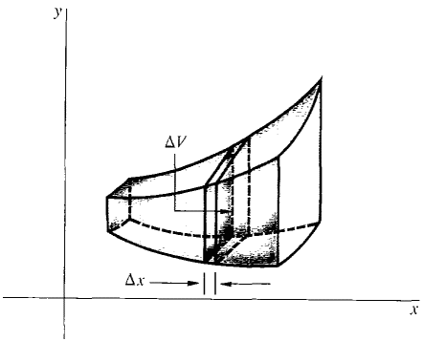
Figure 4
and thus its volume is given by
ΔV ≈ A(x) Δx (compared to Δx).
(The infinitesimal error arises because the area of the cross section changes slightly between x and x + Δx.) Then by the Infinite Sum Theorem,
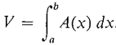
The pattern used in justifying the two formulas in this section will be repeated again and again. First find a formula for an infinitesimal piece of volume ΔV. Then apply the Infinite Sum Theorem to get an integration formula for the total volume V.

STEPS IN FINDING VOLUMES BY SLICING
DEFINITION: | The volume of a solid of a known integrable cross-section area A (x) from x = a to x = b is the integral of A from a to b:  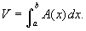

Here are the steps that we should follow to find a volume by slicing.

1. | Sketch the solid (or the base of the solid) and a typical cross section.
2. | Find a formula for A (x).
3. | Find the limits of integration.
4. | Integrate A (x) to find the volume.

EXAMPLE 3: | Find the volume of the solid that lies between planes perpendicular to the x-axis at x = 0 and x = 4. The cross sections perpendicular to the x-axis between these planes run from one side of the parabola x = y ² to the other. The cross sections are squares with bases in the xy-plane.

SOLUTION:  Here is the graph of the base of this solid.  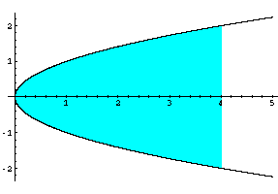  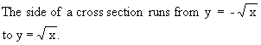 | Here is a picture of the cross section.  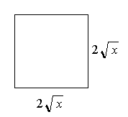
The limits of integration start at x = 0 and go to x = 4.
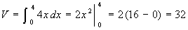

EXAMPLE 4: | Find the volume of the solid that lies between the planes perpendicular to the x-axis at x = -1 and x = 1. The cross sections perpendicular to the x-axis are circular disks whose diameters run from the parabola y = x ² to the parabola y = 2 - x ².

SOLUTION:  Here is the graph of the base of this solid.  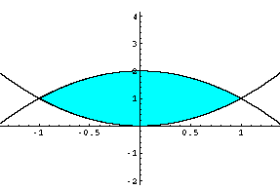 | We are given that the cross sections are circles whose diameters run from y = x ² to y = 2 - x ².  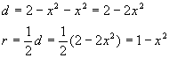  The area of a cross section is  Limits of integration are x = -1 and x = 1.

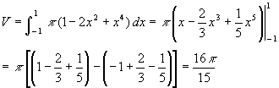

EXAMPLE 5: | Find the volume of the solid that lies between planes perpendicular to the y-axis at y = 0 and y = 2. The cross sections perpendicular to the y-axis are circular disks with diameters running from the y-axis to the parabola

SOLUTION:  Here is the graph of the base of this solid.  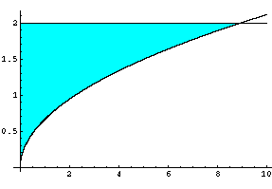 | The cross sections of this solid are circles whose diameters run from the y-axis to the parabola  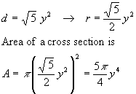

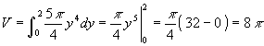
Visit the website: http://mathdemos.gcsu.edu/mathdemos/solids/
http://www.ies.co.jp/math/java/samples/renshi.html
http://demonstrations.wolfram.com/SolidsOfKnownCrossSection/

Example 6: Find the volume of the solid whose base is the region inside the circle x² + y² = 9 if cross sections taken perpendicular to the y-axis are squares.
Because the cross sections are squares perpendicular to the y-axis, the area of each cross section should be expressed as a function of y. The length of the side of the square is determined by two points on the circle x² + y² = 9 (Figure 1 ).
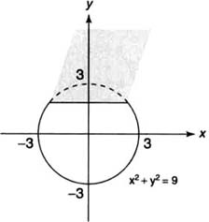

Figure 1 | Diagram for Example 1.

The area ( A) of an arbitrary square cross section is A = s², where
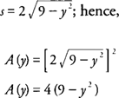

The volume ( V) of the solid is
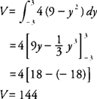

Example 7: Find the volume of the solid whose base is the region bounded by the lines x + 4 y = 4, x = 0, and y = 0, if the cross sections taken perpendicular to the x-axis are semicircles.
Because the cross sections are semicircles perpendicular to the x-axis, the area of each cross section should be expressed as a function of x. The diameter of the semicircle is determined by a point on the line x + 4 y = 4 and a point on the x-axis (Figure 2 ).
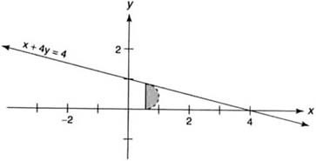

Figure 2 | Diagram for Example 2.

The area ( A) of an arbitrary semicircle cross section is
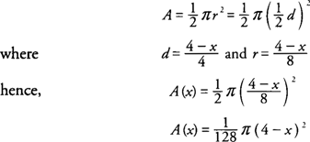

The volume ( V) of the solid is
